BANK MANAGEMENT SYSTEM

# Project Member:

Ms. Nalini.R

Mr.Sasikanth.S

Mr. Sarath.R

Ms. Ragini

Ms. Pranathi

Ms. Nivetha.R

# Guided By :

Prof. Indrakka Mali

# Title :

* Introduction
* Objective
* Technology to be Used
* Proposed System
* Snapshots
* Diagrams
* Advantages
* Conclusion

# Introductoin:

* To Develop a Software for solving Financial applications of a Customer in banking Environment
* A Bank management System is an application for maintaining a persons account in bank.

* The System Provides the Access to customer to Create Account edit,Delete,search accounts.
* Deposits withdraw Cash from our accounts,also to view report of an account.

# Objective :

* The main objective of the The bank management system project is a program that keeps track of a client’s bank account.
* This project demonstrates the operation of a banking account system and covers the essential functions of bank management software.
* It develops a project for resolving a customer’s financial applications in a banking environment to meet the needs of an end banking user by providing multiple ways to complete banking chores.

## This project deals with the various functioning in Bank management process.

* The main idea is to implement a proper process to system .
* The goal of the bank management system project is to create an organic and optimal software of interaction between the various banking components. This is to maximize the profit of the banking mechanism.

The organization can maintain

* computerized records without redundant entries.
* The project’s main goal is to create an online banking system for banks. All banking work is done manually in the current system. To withdraw or deposit money, the user must go to the bank. Today, it is also hard to find account information for people who have accounts in the banking system.

# Software & Hardware used:

**Software Requirements :**

* Operating System : Windows 7 or Windows 10
* Language : Java
* IDE : Spring Tool Suite,
* Client : PostMan
* Backend : Microsoft MySQL server

## Hardware Requirements :

* CPU : Intel Pentium IV processor
* RAM : 4 GB or above
* Hard Disk : 64 GB hard disk space or minimum

# Proposed System:

* The college management system helps Educational Institutions especially colleges in various ways, such as storing data, maintain student profiles, analyzing administrative and academic data, improving communication, and engaging students.

## This is a web-related application that permits us to approach the entire knowledge regarding the college, students, faculties etc.

* This application is also called as College management system. It offers an actual trip of the college campus.
  + First we have to run the Application on the browser, the index page will be shown after that if the user is registered then he/she can login the page and he/she can entering in the application.
  + If the user is not registered then he/she needs to register themselves and then he/she can continuing to login and he/she can access any time.
  + After that related pages will be there like if user is admin so he/she can access all the operations like insert, delete, update and search the details.
    - If the user is customer then he/she can view the related record and he/she can update the record.
    - And after that he/she can logged out by themselves.

# Back-End :

* + - * Core Java
      * Spring Boot
      * Spring Data JPA
      * Hibernate

Spring Boot Web

MySQL Database JUnit

# About Back-End:

* There are mainly four operations will be performed by the user and admin Ex. Insert, update, retrieve/fetch, delete.
* These operation will be performed using the spring boot framework, core java and spring boot web , spring data Jpa , and hibernate.
* And thymeleaf is the design pattern for the user interface.
* For connectivity purpose we are using MySQL database. It is connected to the java and database

# Working Of Back-End ;

* + There are mainly three stages

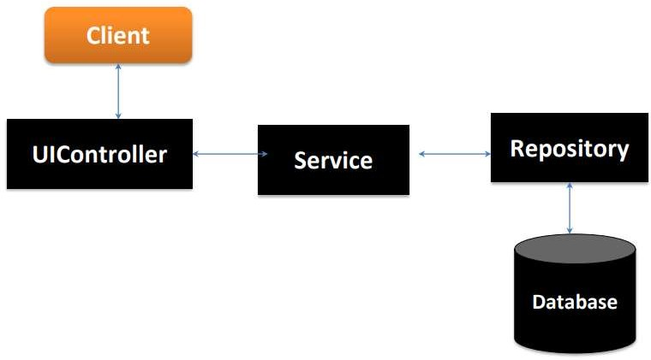

* + - UIController - In Spring Boot, the UIController class is responsible for processing incoming requests, preparing a model, and returning the view to be rendered as a response.
    - Service - Components are the class file which contains @Service annotation.
    - These class files are used to write business logic in a different layer.
  + Repository - Repository is a specialization of @Component annotation which is used to indicate that the class provides the mechanism for storage, retrieval, update, delete and search operation on objects
  + Repository is directly connected with the database and then it can return to the repository and response to the service and it can return to the controller and then response send to the client.

# Advantages:

* + - Better and improved admission rate
    - Better teacher performance
    - Drastic reduction in manual tasks
    - Elimination of paper based tasks
    - Improved fee management
* Makes the institute smart and ready for the future.

Improved institute reputation

better resource utilization

* Duplication of the student and teacher data is avoided.

**snap shots:**

Admin:

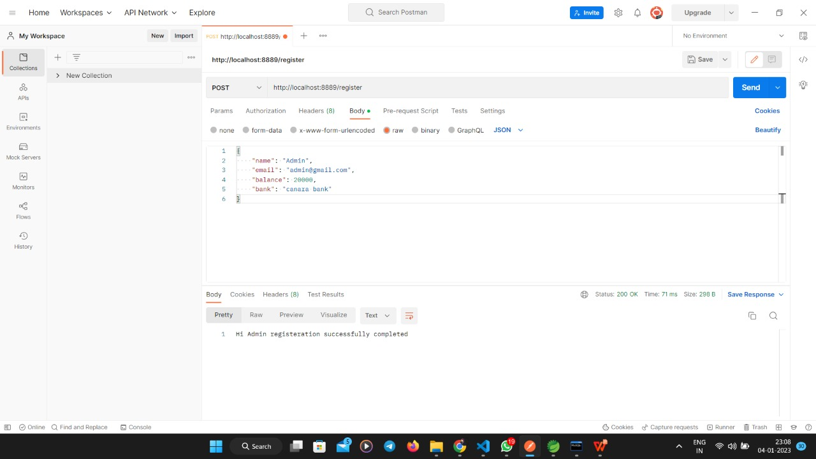

Get All Student Details:

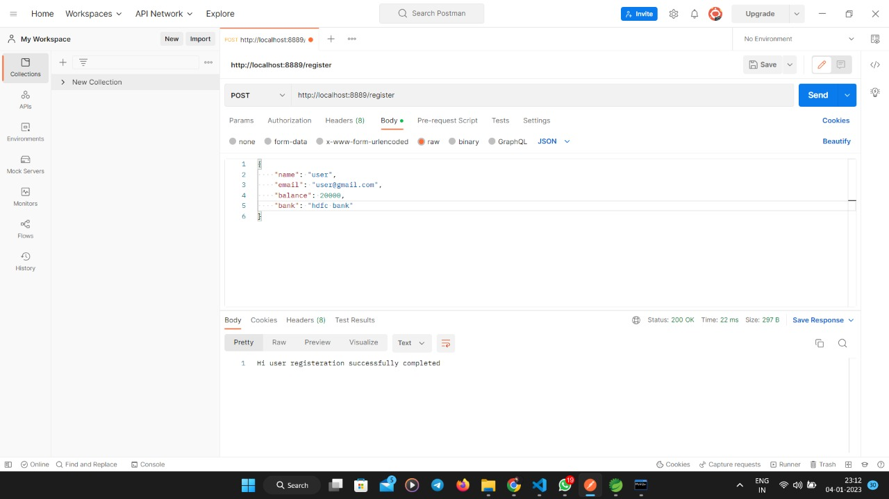

Update :

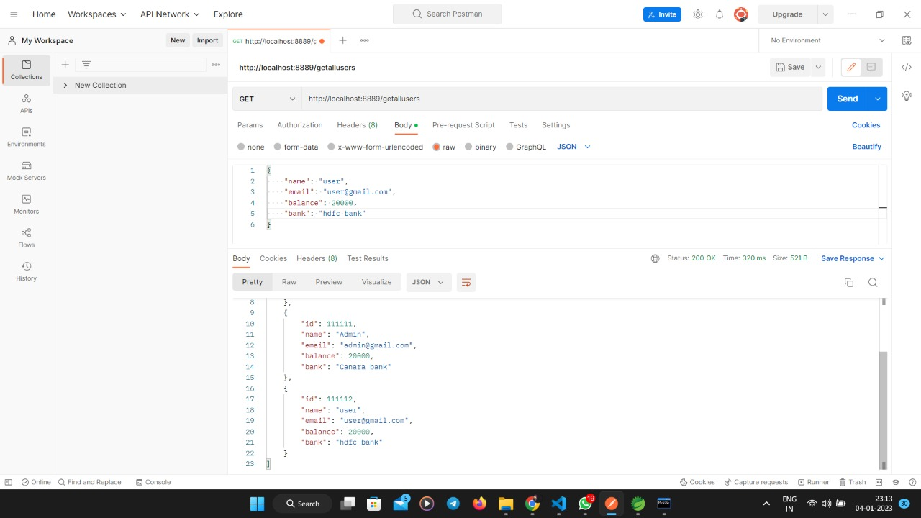

Admin Id:

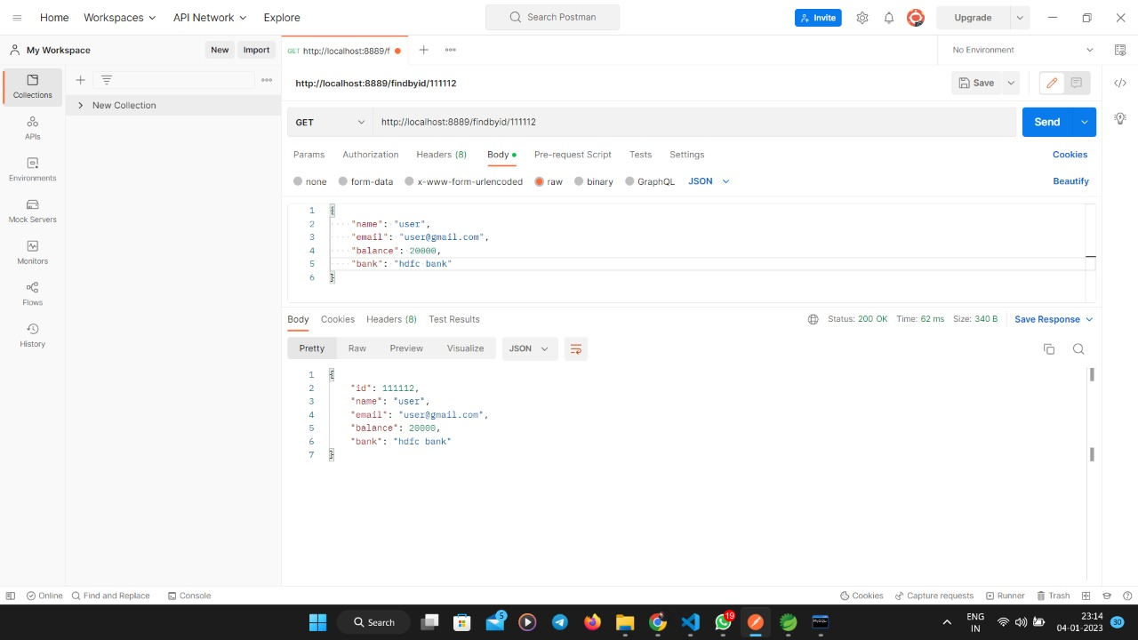

Get Id:

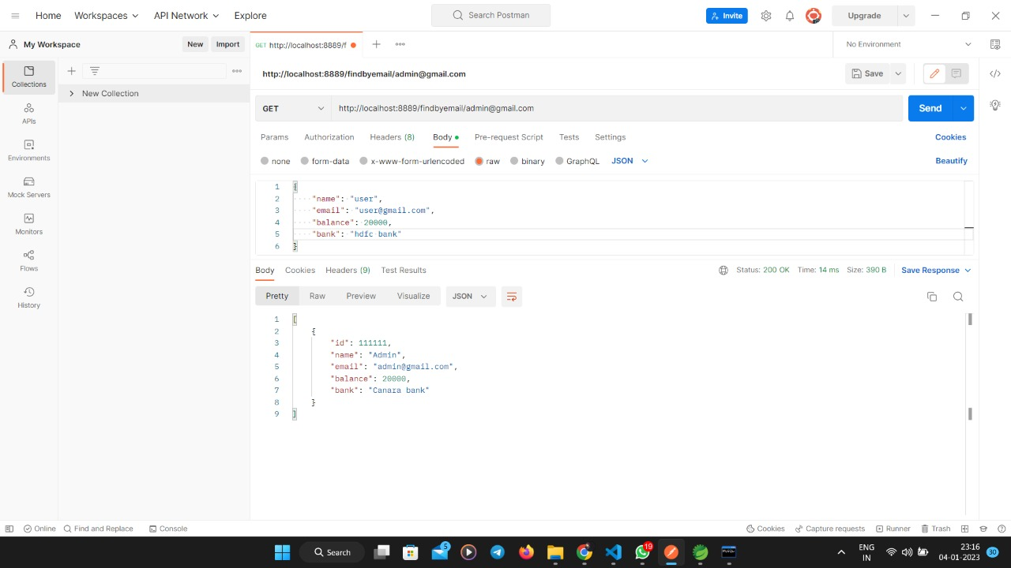

Front End:

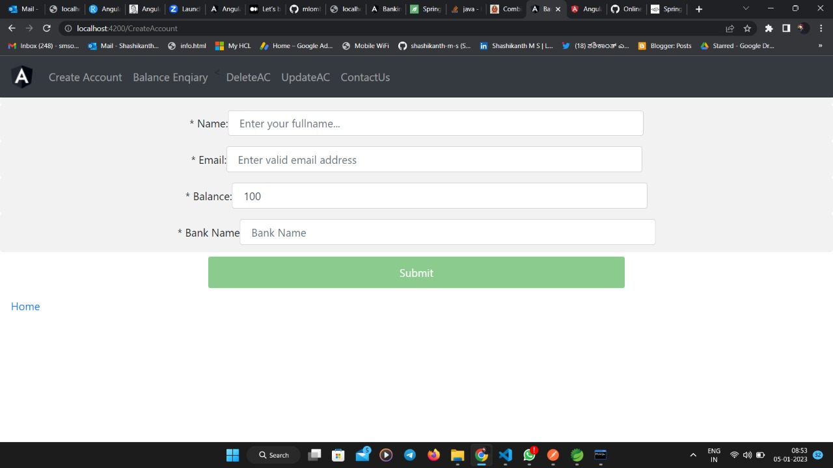

Cont :

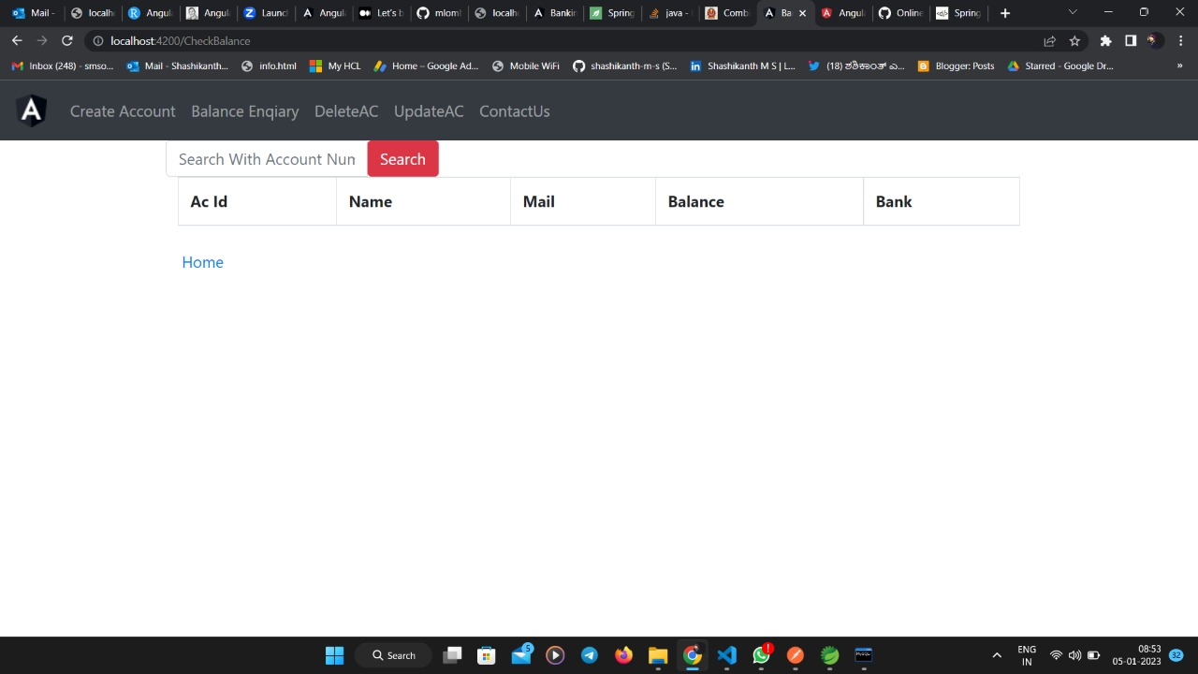

cont:

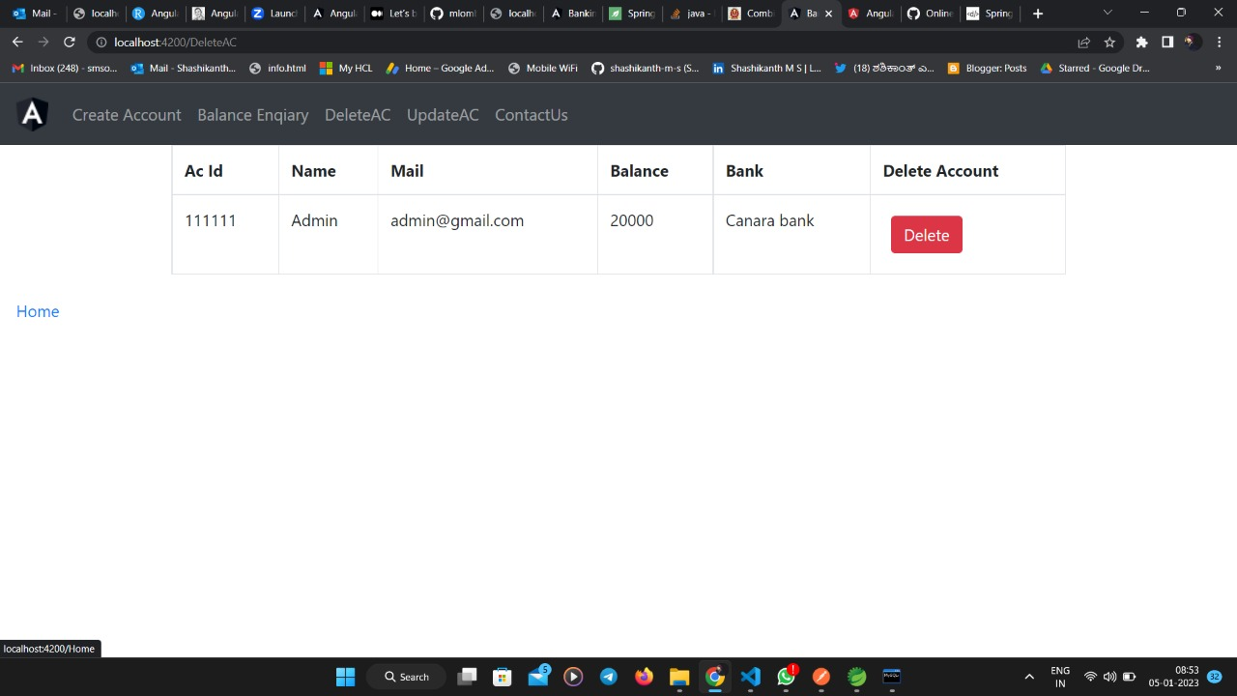

Update:

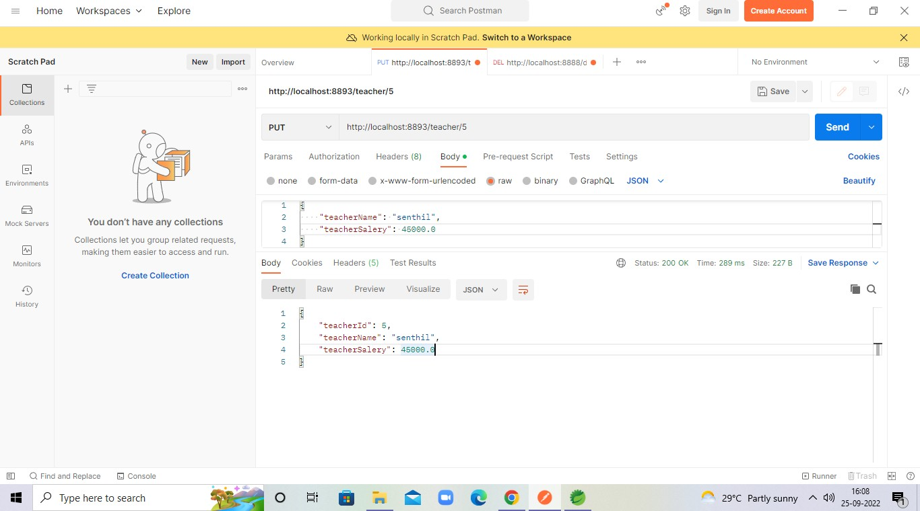

Delete By Id:

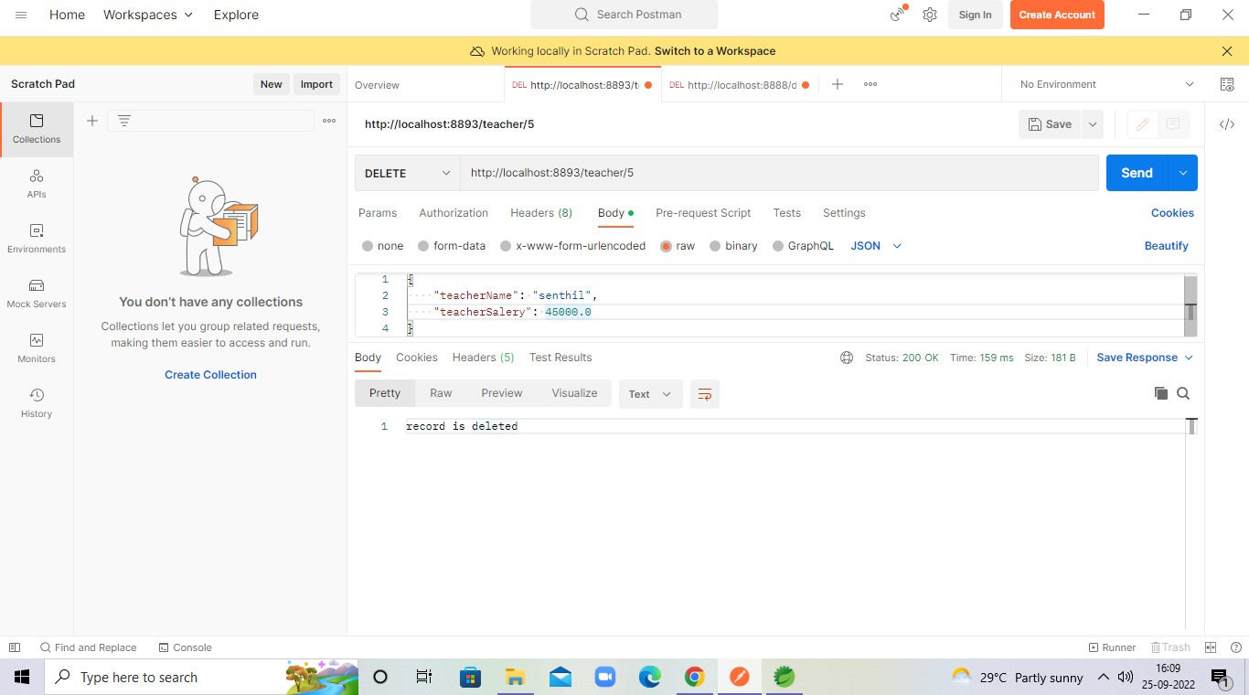

Add Subject:

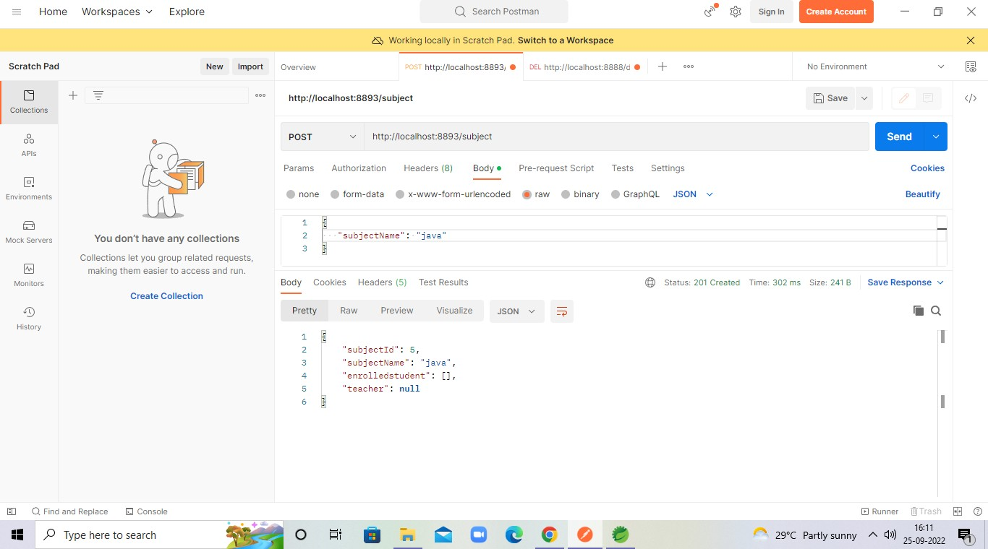

Get All Subject:

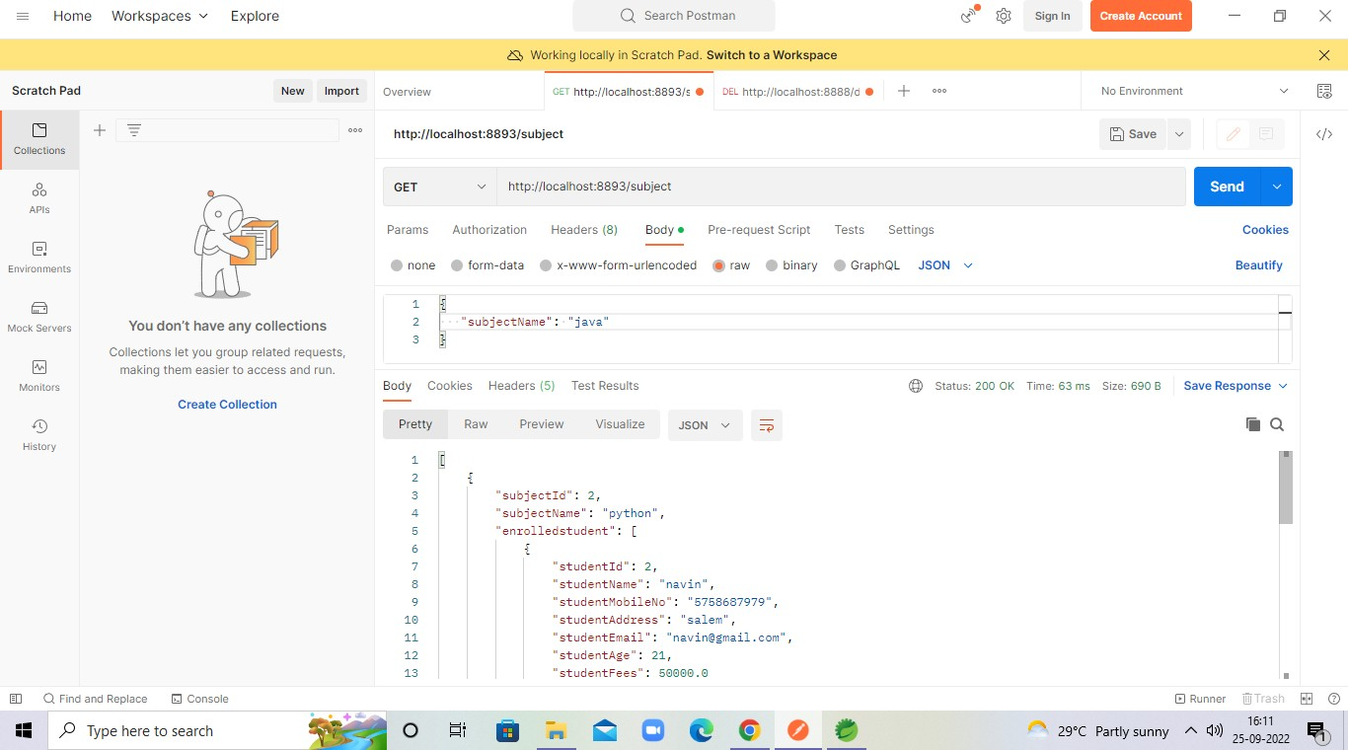

Get Subject By Id:

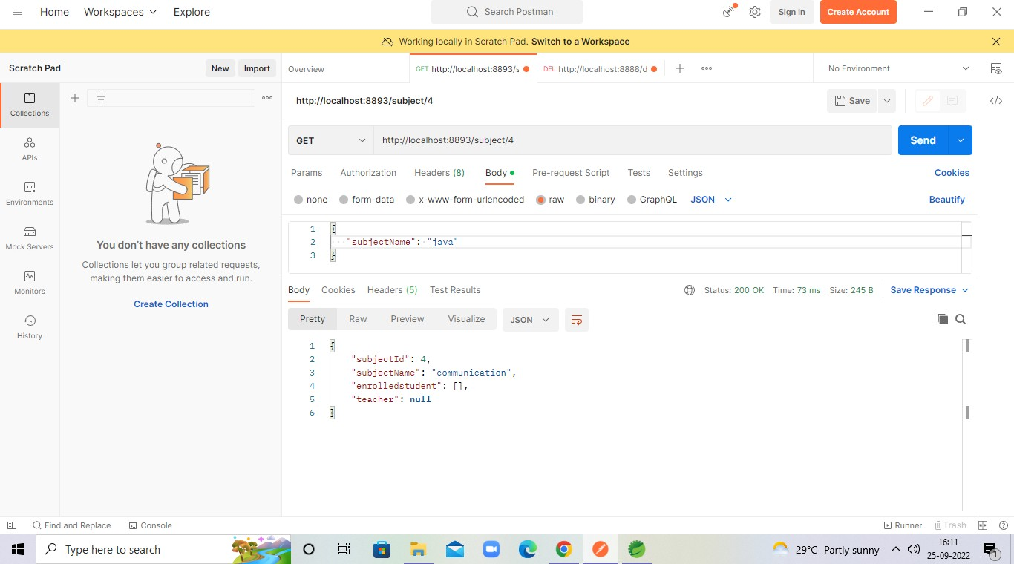

Update Subject:

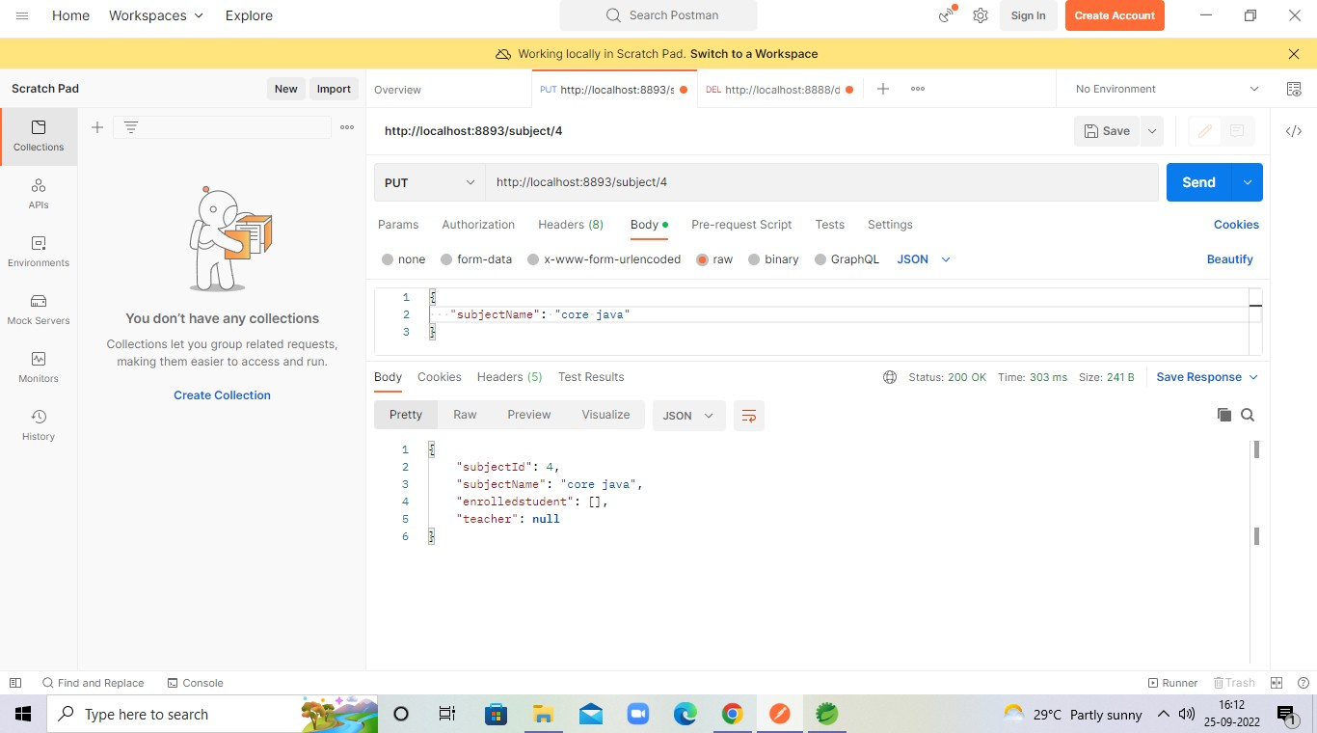

Delete Subject By Id:

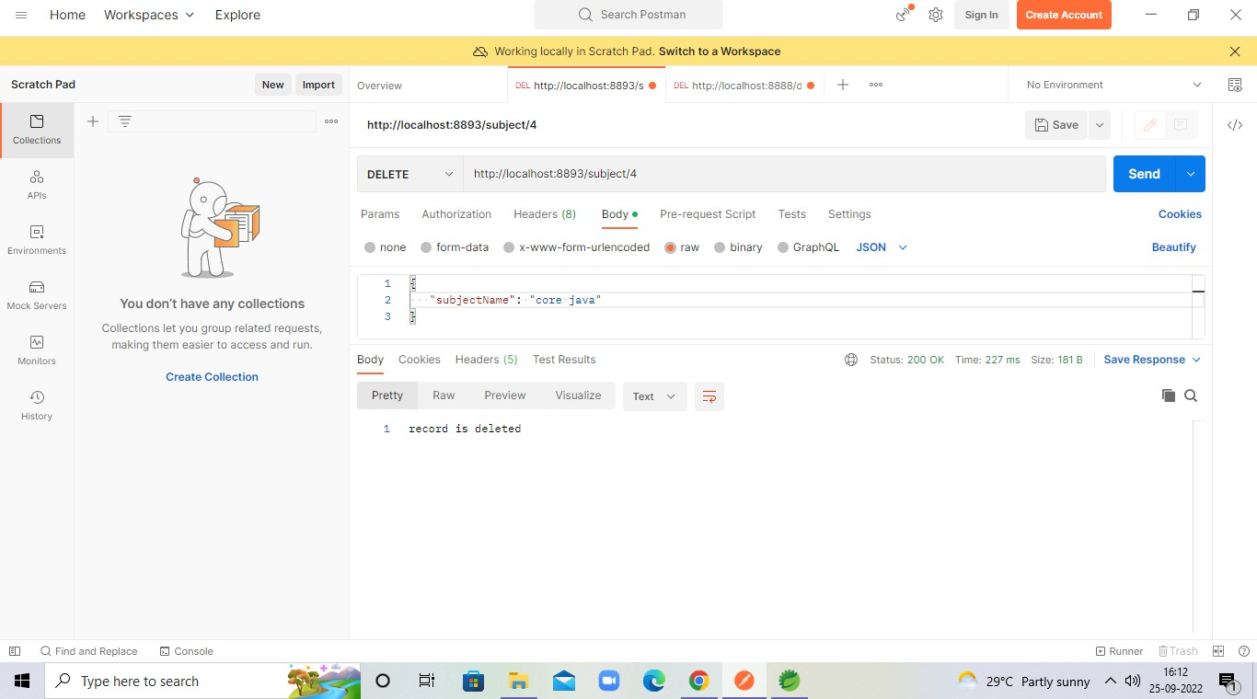

Assign Subject To Student:

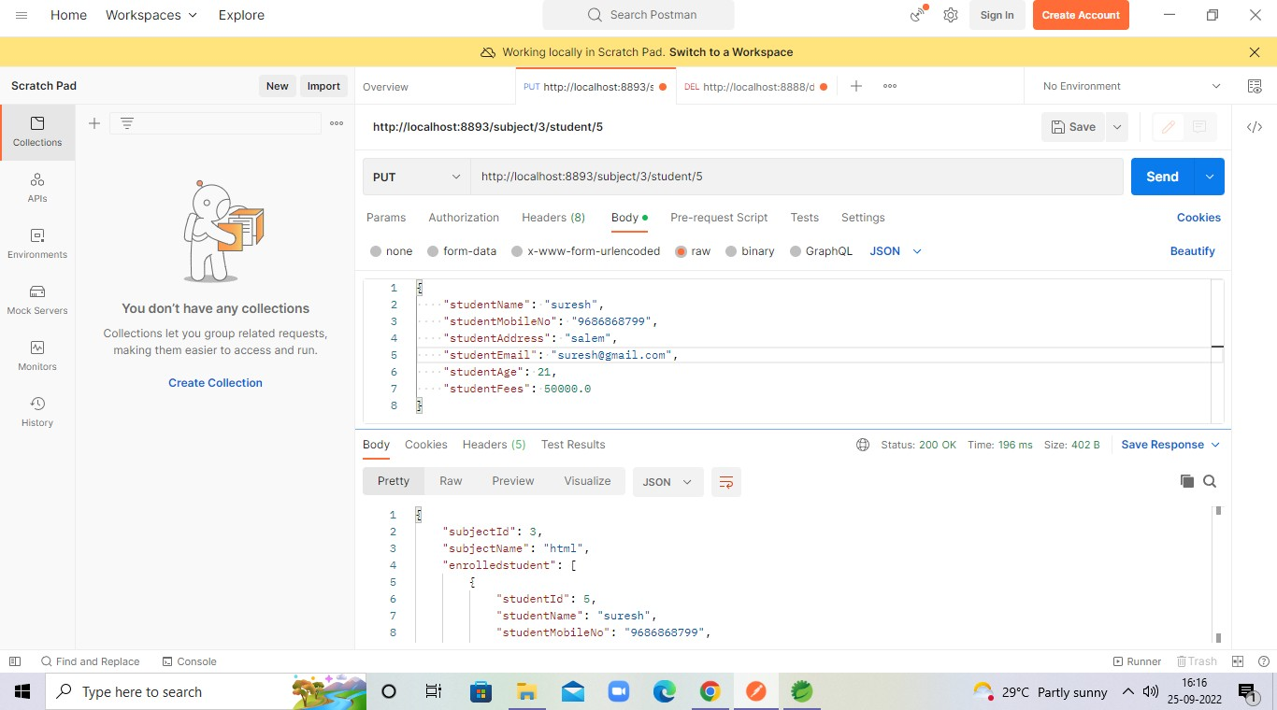

Profit and Loss:

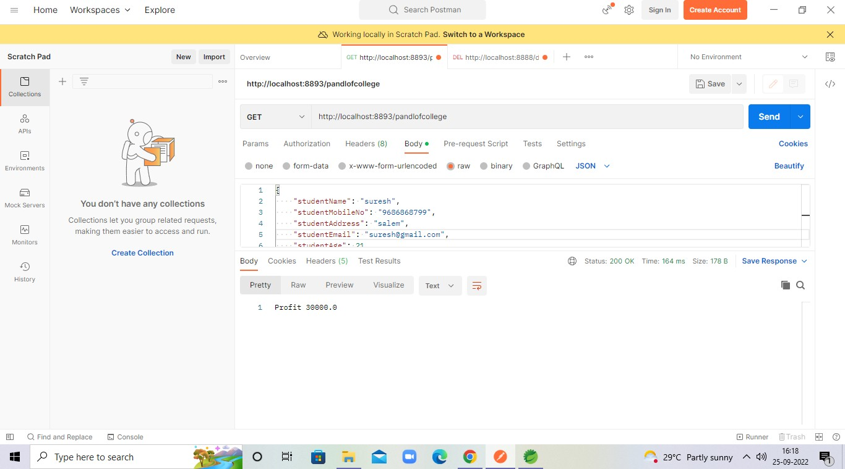

# Conclusion :

* + E-banking offers a higher level of convenience for managing one’s finances. However, it continues to present challenges to financial security and personal privacy. But through this project may upgrade the personal security.
  + This project is successfully implemented with all the features mentioned in system requirements specification.
  + So this serves the right purpose in achieving the desired requirements of both the communities.